Count Odd Numbers in interval range
Platform: LeetCode
Language: C
Module 3, Question 4

Problem Link
https://leetcode.com/problems/count-odd-numbers-in-an-interval-range/

Problem Statement
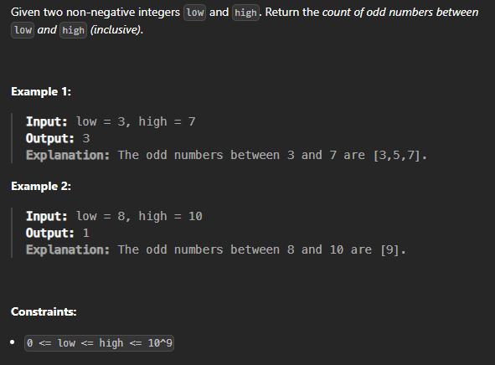

C Code
int countOdds(int low, int high) {
return (high + 1) / 2 - low / 2;
}

Screenshot of Successful Submission



